CHAPTER 11
EQUILIBRIUM AND ELASTICITY
Discussion Questions
Q11.1 Yes, there is no net external force and no net external torque, if the center of mass of the object has zero acceleration and if the rotating object has zero angular acceleration. Each part of the body is not in equilibrium. Each part is moving in uniform circular motion and has a radial acceleration.

Q11.2 (a) Yes. The net force can be zero while the net torque is not zero. For example, there can be two forces acting on the object that are equal in magnitude and opposite in direction. If these forces act at different points on the object they can produce a net torque even though the net force is zero. A simple example of an object in translational equilibrium but not in rotational equilibrium is the cylinder in Fig. 10.9a. (b) Yes. There can be a net force but no net torque. A simple example is a baseball falling without air resistance. There is a net downward force due to gravity but that force acts at the center of gravity of the baseball and produces no torque.

Q11.3 When the wheel no longer tips the added weights have put the center of gravity at the geometrical center of the wheel.

Q11.4 No. The center of gravity of a hollow sphere is at the center of the sphere.

Q11.5 The gravity force on mass 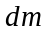is greater at the lower end of the rod so the center of gravity is below the center of mass. The gravity force acting at the center of gravity produces a torque on the object about the object’s center of mass. This torque orients the object. When the long axis of the object is directed toward the earth, the line of action of the gravity force is along the long axis and produces no torque and this then is a stable orientation. The same effect keeps the long axis of the moon oriented along the line between the center of the moon and the center of the earth.

Q11.6 If the object is suspended at the center of gravity a small rotation of the object does not produce any torque and the equilibrium is neutral. For a point of suspension above the center of gravity, a small rotation of the object produces a restoring torque and the object is in stable equilibrium. For a point of suspension below the center of gravity, a small rotation of the object produces a torque that tends to take the object farther from equilibrium and the object is in unstable equilibrium.

Q11.7 To balance on your tiptoes your body must move forward enough to place your center of gravity directly above your toes. When you are standing next to the wall and facing it, the wall prevents this from happening.

Q11.8 When the horseshoe hangs in equilibrium, the gravity torque on it is zero and the center of gravity of the horseshoe is directly below the point of support. Draw a chalk line on the wall behind the string. Pivot the horseshoe about another nail hole and again draw a chalk line along the string. The center of gravity is where these two lines intersect. The center of gravity will not be within the solid material of the horseshoe.

Q11.9 The torque due to the weight of the combined object can be calculated by assuming that the gravity force acts at the center of gravity. Therefore, there is no torque about this point and the object doesn’t rotate. The bar remains horizontal as it falls.

Q11.10 The torque about the center of gravity due to the gravity force is still zero and the bar remains at 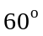 above the horizontal as it falls.

Q11.11 The free-body force diagram for the water skier is given in Fig. DQ11.11. 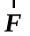is the force of the tow rope and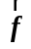is the resistive force exerted by the water. She leans backward to increase the moment arm and hence the torque produced by her weight about an axis at her feet. This torque opposes the torque due to the force applied to her by the tow rope. must equal the resistive force . When her speed increases, 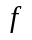increases and 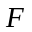increases so she must lean back farther to increase the gravity torque.

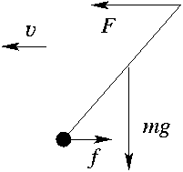

Figure DQ11.11

Q11.12 Pushing near the rim of the wheel gives greater torque about the axle than pushing on the wagon, since the pushing force has a larger moment arm.

Q11.13 He cannot do this. As soon as a vertical line through his center of gravity extends beyond his toes there will be a net torque on him for a horizontal axis through his center of gravity and he will fall over.

Q11.14 With your arm extended there is a large torque about your shoulder due to the weight of the dumbbell and your muscles must exert an equal opposing torque.

Q11.15 I know from experience that over time the distribution of a person’s body mass changes, for example moving toward their midsection. This redistribution of mass changes both the location of the person’s center of gravity and also the moment of inertia about an axis through the center of mass.

Q11.16 They add more weight in their abdomen region, extending away from their spine. They have to lean backward a bit to keep their center of gravity from extending horizontally past their feet.

Q11.17 The glass tips when its center of gravity is above a point beyond the bottom edge of the glass. If the water in the glass raises the center of gravity this will make the glass more unstable. Whether or not this will be the case depends on how the mass of the glass is distributed. Adding water does increase the moment of inertia, so more torque is required to start it rotating away from equilibrium.

Q11.18 To slide the refrigerator the horizontal force you apply must equal the force of friction from the floor. Whether it starts to slide first or tip first depends on how far above the floor you push. The higher up you push the greater the moment arm for your force and the more torque it produces for a given magnitude of force.

Q11.19 The tension in the wire has a component to the right and the weight of the bar is a vertical force so the force the hinge exerts must have a component to the left. The tension in the wire has an upward component and the weight of the bar is a downward force so you can’t use the vertical forces to decide if the hinge force has an upward or downward component. Consider torques on the bar for an axis at the point where the wire is attached to the bar. For this axis, the weight of the bar produces a counterclockwise torque. The torques must sum to zero so the hinge force must produce a clockwise torque and the vertical component of the hinge force is downward.

Q11.20 The Young’s modulus of a wire depends only on the material of which the wire is made and does not depend on the length or cross-sectional area of the wire.

Q11.21 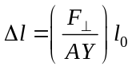. 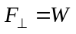 and 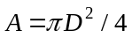, so 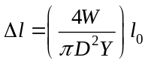. For the new value of W, 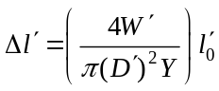. But 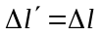 and 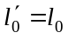 (same original length, same amount of stretch). This gives 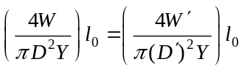. 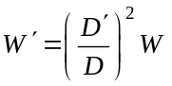. 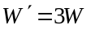 gives 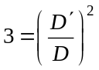 and 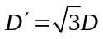.

Q11.22 They have the same tensile strength but the cable is much more flexible. This can be an advantage or disadvantage depending on the application.

Q11.23 The weight of the elephant is much greater so the same stress requires bones of greater cross section.

Q11.24 The excess energy in each deformation cycle is deposited in the tendon and can build up to damaging levels after a large number of rapid cycles.

Q11.25 The excess energy during each vibration cycle is deposited as thermal energy in the rubber mounting blocks.

